Ocoee Model CAR Club

APRIL 29, 2017

Present’s THE 3RD ANNUAL

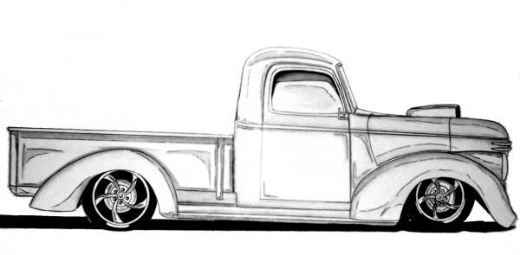**WHITE WATER CLASSIC**

Ocoee Model

Car Club

# 

# **THEME: FAT FENDERED PICKUPS**

**PEERLESS ROAD CHURCH 1200 DAVIS DRIVE CLEVELAND TN. 37312**

**PRICE ADMISSION $2.00 CONTEST ENTRY $10.00 Unlimited**

**Registration 8:30 am -12pm Judging 12 pm -1:30 Awards 4PM**

**TOP 15 AWARDS**

**SPECIALTY AWARDS includes:**

**Best of Show, Best Jr., BEST PAINT, BEST GM, BEST FORD & MOPAR**

**Contact Information:**

**Chip Rymer 423-595-8964 /Shane Harrold 423-331-8430**

**Vendor contact is Chip Rymer 423-595-8964**

VENDER TABLES $25.00 AFTER 4/14/2017 $35.00 (SET UP @ 7am)

www.ocoeemodelcarclub@gmail.com / www.facebook.com/OcoeeModelClub

