
BUNKERMANIA 2026
PLASTIC MODEL SHOW
AND CONTEST
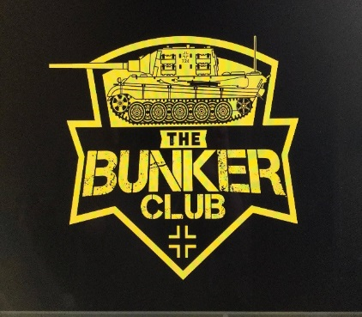
Saturday, November 7th Quality Inn and Suites
1545 WAYNE AVE
INDIANA, PA
ADMISSION AND REGISTRATION OPEN AT 9AM
REGISTRATION CLOSES AND JUDGING STARTS AT 12PM
AWARDS TO FOLLOW
CONCESSIONS
VENDORS
RAFFLES

GENERAL ADMISSION $5, UNDER 12 FREE
$10 ADULT ENTRY FEE FOR FIRST 3 MODELS ($1 FOR EACH ADDITIONAL MODEL)
$3 JUNIOR ENTRY FEE (UNLIMITED MODELS)

SPECIAL AWARDS INCLUDE:
- BEST IN SHOW OVERALL (CHAMPIONSHIP RING AWARDED)
- BEST OVERALL ARMOR (CHAMPIONSHIP BELT AWARDED)
- BEST OVERALL AIRCRAFT (CHAMPIONSHIP BELT AWARDED)
- BEST OVERALL AUTOMOBILE (CHAMIONSHIP BELT AWARDED)
- BEST KOREAN ARMOR (SGT. GEORGE FRITZ AWARD)
- BEST JAGTIGER TANK (THE BUNKER CLUB MASCOT)
- BEST 1/16 SCALE MODEL
- BEST SHERMAN TANK
- BEST RUSSIAN, BRITISH, AND GERMAN ARMOR
- BEST LUFTWAFFE
- BEST MARINE CORP MODEL
- BEST ARTILLERY
- BEST BRITISH MODEL
- PRESIDENT’S CHOICE (BUNKER CLUB PRESIDENT’S PICK)
- BEST JUNIOR MODEL
- BEST YOUTH MODEL
- BEST DINOSAUR
- BEST FIGURE
- BEST SHIP
- BEST HORROR MODEL
- BEST SCI-FI MODEL
- BEST MISCEALLANEOUS
- BEST MOVIE MODEL
- BEST DIORAMA
- BEST BUST
- BEST SPACE MODEL
CONTEST CATEGORIES:
AIRCRAFT
ARMOR
AUTOMOTIVE
BUSTS
DINOSAURS
DIORAMAS
FIGURES
GUNDAM
HORROR
JUNIORS (AGES 13-17)
MISCEALLANEOUS
MOVIES
SCI-FI
SHIPS
SPACE
WARHAMMER
YOUTH (AGES 12 AND YOUNGER)


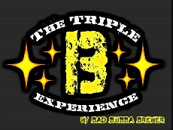

IPMS SANCTIONED EVENT
DISCOUNTED ROOMS AVAILABLE AT THE QUALITY INN, JUST MENTION “BUNKERMANIA” WHEN RESERVING
FOR MORE INFORMATION, JOIN
“THE BUNKER CLUB” ON FACEBOOK
CALL, TEXT, EMAIL TROY FRITZ
724-599-4885
FRANKCASTLE31@YAHOO.COM
VENDOR TABLE FEE $30
SPONSERS:

