
BUNKERMANIA 2021
PLASTIC MODEL SHOW
AND CONTEST
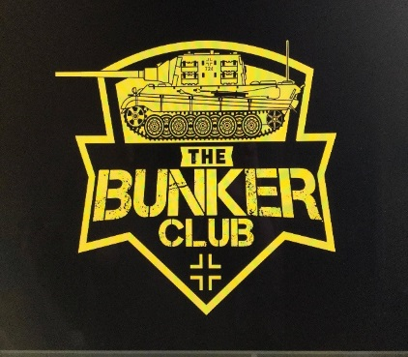
Saturday, November 13th Clyde Fire Hall
CONCESSIONS
VENDORS
RAFFLES
1050 CLYDE ROAD
NEW FLORENCE, PA
ADMISSION AND REGISTRATION OPEN AT 9AM
REGISTRATION CLOSES AND JUDGING STARTS AT 12PM
AWARDS TO FOLLOW
GUEST ANNOUNCER
BAD BUBBA BREWER
GENERAL ADMISSION $3, UNDER 12 FREE
$10 ADULT ENTRY FEE FOR FIRST 3 MODELS ($1 FOR EACH ADDITIONAL MODEL)
$3 JUNIOR ENTRY FEE (UNLIMITED MODELS)

SPECIAL AWARDS INCLUDE:
- BEST OVERALL ARMOR (CHAMPIONSHIP BELT AWARDED)
- BEST OVERALL AIRCRAFT (CHAMPIONSHIP BELT AWARDED)
- BEST KOREAN ARMOR (SGT. GEORGE FRITZ AWARD)
- BEST JAGTIGER TANK (THE BUNKER CLUB MASCOT)
- BEST RUSSIAN ARMOR
- BEST LUFTWAFFE
- BEST MARINE CORP MODEL
- BEST JUNIOR MODEL
- BEST YOUTH MODEL
- BEST CAR MODEL
- BEST DINOSAUR
- BEST FIGURE
- BEST SHIP
- BEST HORROR MODEL
- BEST SCI-FI MODEL
- BEST MOVIE MODEL
- BEST DIORAMA
- BEST BUST
- BEST SPACE MODEL

CONTEST CATEGORIES:
AIRCRAFT
ARMOR
AUTOMOTIVE
BUSTS
DINOSAURS
DIORAMAS
FIGURES
HORROR
JUNIORS (AGES 13-17)
MOVIES
SCI-FI
SHIPS
SPACE
YOUTH (AGES 12 AND YOUNGER)

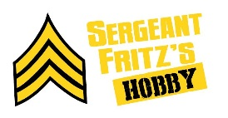
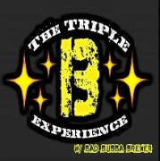
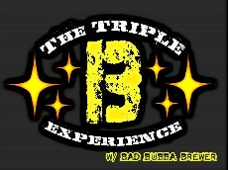

SPONSORS:
FOR MORE INFORMATION
CALL, TEXT, OR EMAIL TROY FRITZ
724-599-4885
FRANKCASTLE31@YAHOO.COM

VENDOR TABLE FEE $10
SPONSERS:

