
BUNKERMANIA 2020
PLASTIC MODEL SHOW
AND CONTEST
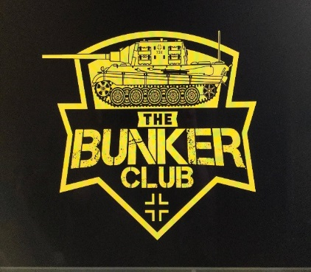
Saturday, November 14th Clyde Fire Hall
VENDORS
REFRESHMENTS
RAFFLES
1050 CLYDE ROAD
NEW FLORENCE, PA
ADMISSION AND REGISTRATION OPEN AT 9AM
REGISTRATION CLOSES AND JUDGING STARTS AT 12PM
AWARDS TO FOLLOW
GUEST ANNOUNCER
BAD BUBBA BREWER
CONTEST CATEGORIES:
AIRCRAFT
ARMOR
AUTOMOTIVE
DINOSAURS
DIORAMAS
FIGURES
JUNIORS (AGES 13-17)
YOUTH (AGES 12 AND YOUNGER)
SCI-FI
SPACE
MOVIES
SHIPS
1/144, 1/100, 1/72, 1/56 SCALE

GENERAL ADMISSION $3, UNDER 12 FREE
$10 ADULT ENTRY FEE FOR FIRST 3 MODELS ($1 FOR EACH ADDITIONAL MODEL)
$3 JUNIOR ENTRY FEE (UNLIMITED MODELS)
WE POLITELY ASK YOU WEAR A MASK TO KEEP EVERYONE SAFE

SPECIAL AWARDS INCLUDE:
- BEST OVERALL ARMOR (CHAMPIONSHIP BELT AWARDED)
- BEST OVERALL AIRCRAFT (CHAMPIONSHIP BELT AWARDED)
- BEST KOREAN ARMOR (SGT. GEORGE FRITZ AWARD)
- BEST JAGTIGER TANK (THE BUNKER CLUB MASCOT)
- BEST RUSSIAN ARMOR
- BEST LUFTWAFFE
- BEST MARINE CORP MODEL
- BEST JUNIOR MODEL
- BEST YOUTH MODEL
- BEST CAR MODEL
- BEST DINOSAUR
- BEST FIGURE
- BEST SHIP
- BEST HORROR MODEL
- BEST SCI-FI MODEL
- BEST MOVIE MODEL
- BEST DIORAMA
- BEST BUST
- BEST SPACE MODEL


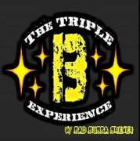
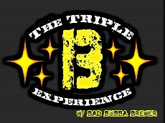

SPONSORS:
FOR MORE INFORMATION VISIT
WWW.FACEBOOK.COM/SGTFRITZSHOBBIES
OR
CALL, TEXT, OR EMAIL TROY FRITZ
724-599-4885
FRANKCASTLE31@YAHOO.COM
VENDOR TABLE FEE $10
SPONSERS:

