
BUNKERMANIA 2019
PLASTIC MODEL SHOW
AND CONTEST
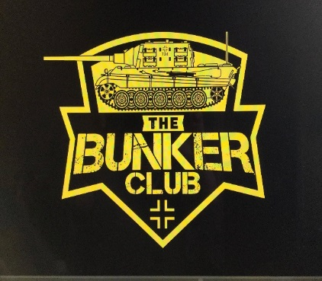
Saturday, November 9th Clyde Fire Hall
CONCESSIONS
RAFFLES
VENDORS
1050 CLYDE ROAD
NEW FLORENCE, PA
ADMISSION AND REGISTRATION OPEN AT 9AM
REGISTRATION CLOSES AND JUDGING STARTS AT 12PM
AWARDS TO FOLLOW
GUEST ANNOUNCER
BAD BUBBA BREWER
GENERAL ADMISSION $3, UNDER 12 FREE
$10 ADULT ENTRY FEE FOR FIRST 3 MODELS ($1 FOR EACH ADDITIONAL MODEL)
$3 JUNIOR ENTRY FEE (UNLIMITED MODELS)
ALL ARE WELCOME

SPECIAL AWARDS INCLUDE:
- BEST OVERALL ARMOR (CHAMPIONSHIP BELT AWARDED)
- BEST OVERALL AIRCRAFT (CHAMPIONSHIP BELT AWARDED)
- BEST KOREAN ARMOR (SGT. GEORGE FRITZ AWARD)
- BEST JAGTIGER TANK (THE BUNKER CLUB MASCOT)
- BEST RUSSIAN ARMOR
- BEST COLD WAR ARMOR
- BEST DESERT STORM TO PRESENT ARMOR
- BEST 1/16 SCALE ARMOR
- BEST LUFTWAFFE
- BEST WWII AIRCRAFT
- BEST MARINE CORP MODEL
- BEST JUNIOR MODEL
- BEST YOUTH MODEL
- BEST WWI ARMOR
- BEST WWII ARMOR
- BEST AIRCRAFT KOREAN WAR TO PRESENT
- BEST CAR MODEL
- BEST DINOSAUR
- BEST SMALL SCALE ARMOR/AIRCRAFT/FIGURE

CONTEST CATEGORIES:
AIRCRAFT
ARMOR
AUTOMOTIVE
DINOSAURS
DIORAMAS
FIGURES
JUNIORS
YOUTH (AGES 12 AND YOUNGER)
SCI-FI/SPACE/MOVIES
SHIPS
1/144, 1/100, 1/72, 1/56 SCALE

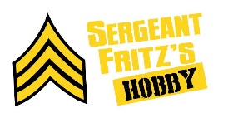
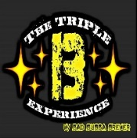
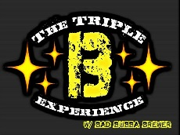

SPONSORS:
FOR MORE INFORMATION VISIT
WWW.FACEBOOK.COM/SGTFRITZSHOBBIES
OR
CALL, TEXT, OR EMAIL TROY FRITZ
724-599-4885
FRANKCASTLE31@YAHOO.COM
VENDOR TABLE FEE $10
SPONSERS:

