BUNKER BRAWL 2021
PLASTIC MODEL SHOW AND CONTEST
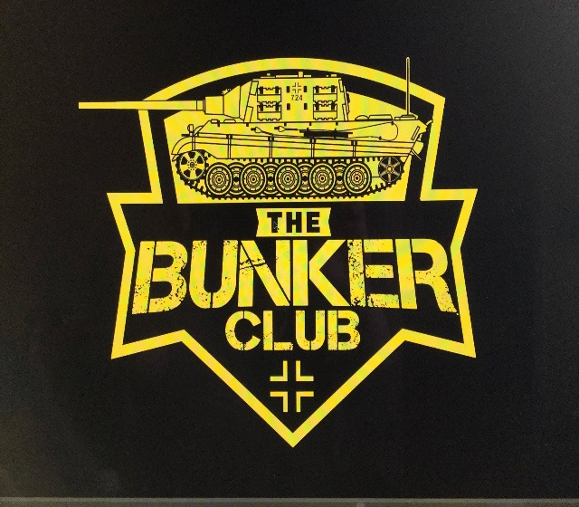
Saturday, May 1st Clyde Fire Hall
REFRESHMENTS
RAFFLES
VENDORS
1050 CLYDE ROAD
NEW FLORENCE, PA
ADMISSION AND REGISTRATION OPEN AT 9AM
REGISTRATION CLOSES AND JUDGING STARTS AT 12PM
AWARDS TO FOLLOW

SPECIAL AWARDS INCLUDE:
- BEST OVERALL ARMOR
- BEST OVERALL AIRCRAFT
- BEST KOREAN ARMOR (SGT. GEORGE FRITZ AWARD)
- BEST JAGTIGER TANK (THE BUNKER CLUB MASCOT)
- BEST RUSSIAN ARMOR (SGT. MAJOR EARL AWARD)
- BEST LUFTWAFFE
- BEST MARINE CORP MODEL
- BEST JUNIOR MODEL
- BEST YOUTH MODEL
- BEST CAR MODEL
- BEST DINOSAUR
- BEST FIGURE
- BEST SHIP
- BEST MISCEALLANEOUS MODEL
- BEST SCI-FI MODEL
- BEST MOVIE MODEL
- BEST DIORAMA
- BEST BUST
- BEST SPACE MODEL

CONTEST CATEGORIES:
AIRCRAFT
ARMOR
AUTOMOTIVE
DINOSAURS
DIORAMAS
FIGURES
JUNIORS (AGES 13-17)
YOUTH (AGES 12 AND YOUNGER)
SCI-FI
SPACE
MOVIES
SHIPS
1/144, 1/100, 1/72, 1/56 SCALE

GENERAL ADMISSION $3, UNDER 12 FREE
$10 ADULT ENTRY FEE FOR FIRST 3 MODELS ($1 FOR EACH ADDITIONAL MODEL)
$3 JUNIOR ENTRY FEE (UNLIMITED MODELS)
WE POLITELY ASK YOU WEAR A MASK TO KEEP EVERYONE SAFE

GUEST ANNOUNCER
BAD BUBBA BREWER


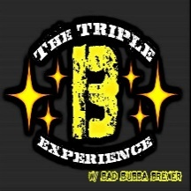

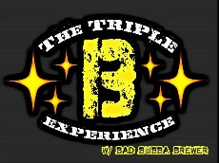
FOR MORE INFORMATION VISIT
SEARCH “THE BUNKER CLUB” ON FACEBOOK
OR
CALL, TEXT, OR EMAIL TROY FRITZ
724-599-4885
FRANKCASTLE31@YAHOO.COM
VENDOR TABLE FEE $10
SPONSORS:
SPONSERS:

