Ocoee Model Car Club
June 9^{th.} 2018
Presents the 4th Annual

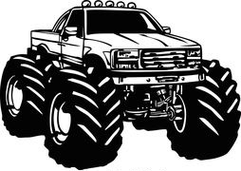
WHITEWATER CLASSIC
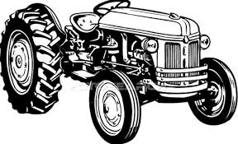

THEME: 4 Wheel Drives

Sub Theme Construction & Farm Equipment (See Facebook Page for Detail)
NO REPEAT PREVIOUS WINNING ENTRIES

PEERLESS ROAD CHURCH 1200 DAVIS DRIVE CLEVELAND TN. 37312
CONTEST ENTRY 3 for $10.00 $1.oo each additional model
GENERAL ADMISSION PRICE $2.00
Registration 9:00 am -1pm Judging 1pm -2:30 pm Awards @ 4 PM
TOP 15 AWARDS SPECIALTY AWARDS includes: Best of Show,
Best JR., Best Interior, Best Engine, Best GM, Best Ford & Mopar
Contact Info: Chip Rymer 423-595-8964 / Shane Harrold 423-331-8430
Vendor contact is Chip Rymer 423-595-8964
VENDOR TABLES $25.00 AFTER 5/9/2018 $35.00 (SET UP @ 8am)
www.ocoeemodelcarclub@gmail.com / www.facebook.com/OcoeeModelClub
